# Network level taxonomy of the core/extended person perception system

# Abstract

Familiar faces prompt the recall of diverse kinds of person-related knowledge (name, occupation, personal experiences, associated social and perceptual traits). The way these diverse forms of information are encoded within the well-characterised face/person selective network (core and extended systems) is still uncertain. To address this issue, we had participants access five different kinds of person knowledge (social, episodic, biographical, physical, nominal) through ten different tasks. By directly comparing different cognitions, we are able to: 1) test relative role of specific cognitive processes in specific brain regions, such as the role of the ATL is social or nominal knowledge and 2) apply a Network level Representational Similarity Analysis (netRSA) to gain insight into underlying systems-level organisation ofperson-knowledge network. netRSA revealed a strong divide between regions involved in internalised cognition (precuneus, mPFC, ATL etc.) and other elements of the person-knowledge network.  Fronto-lateral regions (IFG and OFC) coordinate closely with perceptual regions in the core system (FFA, OFA, pSTS). The recently characterised ‘anterior temporal face patch’ (ATFP) responds when recalling social and physical person knowledge. We also demonstrate hierarchical organisation of cognitions within the network. Pattern of activation during semantic retrieval is more similar to episodic than nominal knowledge and is distinct from the pattern for social and physical knowledge. Collectively the results show coordinated activity within functionally connected units of the network that extends the core-extended divisions as well as providing a hierarchical model of cognitions within the person perception network.

**Highlights**

* **We employ a network-level multivariate approach across the cortical network for person-knowledge**
* **Accessing episodic memories and recalling biographical facts engages the brain in a similar way.**
* **Coordinating of regions across tasks reveals that perceptual lateral frontal regions coordinate more closely with ‘core’ perceptual regions than ‘extended’ non-perceptual regions.**
* **Anterior temporal lobe preferentially responds to social tasks, fitting social knowledge hypothesis**
* **pSTS is functionally heterogenous with separate parts involved in perception and person knowledge.**

# Introduction

Seeing a familiar person brings to awareness a variety of related attributes: biographical facts (semantic knowledge), personal experience (episodic knowledge), physical attributes (perceptual knowledge), trustworthiness (social knowledge) and their name (nominal knowledge).  We use this wealth of person specific information frequently in our day-to-day lives. The question of how this diverse information is represented in the brain is an area of active research.

Neuroimaging studies have identified an interconnected network of regions activated when we see and think about other people (Fairhall & Ishai, 2007; Gobbini & Haxby, 2007; Haxby, Hoffman, & Gobbini, 2000a). This network is composed of a perceptual ‘core system’, the occipital and fusiform face areas (OFA, FFA) (Gauthier, Tarr, Moylan, & Skudlarski, 2000; Kanwisher, McDermott, & Chun, 1997) and the posterior superior temporal sulcus (pSTS). This core is complemented by an ‘extended system’ - a more loosely grouped set of regions implicated in a broad range of person-related cognition unrelated to perception (Haxby, Hoffman, & Gobbini, 2000a). The extended system includes lateral frontal regions: inferior frontal gyri (IFG), lateral orbitofrontal cortex (OFC); regions associated with internalised cognition: the anterior temporal lobes (ATL), precuneus, ventromedial and dorsmomedial prefrontal cortices (vmPFC, dmPFC); and medial temporal regions: the amygdalae and, potentially, the recently identified anterior temporal face patch ATFP (Moeller, Freiwald, & Tsao, 2008; Rajimehr, Young, & Tootell, 2009).

Numerous investigations of the contribution of these regions have produced diverse, and at times discordant, results (c.f. table 1). For example, while the pSTS is classically characterised as a core ‘perceptual’ region, it is frequently linked with social and other person-related cognition unrelated to perception (Adolphs, 2003; Fairhall & Caramazza, 2013a; Koster-Hale et al., 2017), indicative of the marked pSTS functional heterogeneity (Gobbini & Haxby, 2007; Hein & Knight, 2008). Likewise, the varied functional attributions of the of the ATL to proper naming (Grabowski et al., 2001), biographical information(Glosser, Salvucci, & Chiaravalloti, 2003; Olson, Plotzker, & Ezzyat, 2007; Tippett, Miller, & Farah, 2000) and social cognition (Simmons & Martin, 2009) further illustrate the diversity and complexity regional roles across the extended system.

 Ambiguities surrounding diversity and complexity in regional function are expounded by the tendency of researchers to address single cognitive functions in one or a few brain regions. Most regions of the extended system are recruited to some extent across multiple experimental contexts, including simple tasks such as repetition detection(Todorov, Gobbini, Evans, & Haxby, 2007) or superordinate categorization (Fairhall, Anzellotti, Ubaldi, & Caramazza, 2014). In other words, most-all person related cognition involves most-all of the extended system. The important information may not be whether a specific region is modulated by a task but the *relative* change of regional activity across the entire network.  Rather than attributing a function to a region or a region to a function it may be that the representation of cognition within the brain is best described in terms of the patterns of activation over distributed cortical networks.

The importance of network over region is especially important considering that many elements of the extended system fall within one prominent network in the brain, the intrinsic brain network - a collection of brain regions associated with a range of internalised cognitive processes (Spreng, Stevens, Chamberlain, Gilmore, & Schacter, 2010)**.** These include not only the eponymous ‘default mode’, task-deactivated states (Raichle et al., 2001) but also a broad range of internalised cognitive processes:  general semantic knowledge (Binder, Desai, Graves, & Conant, 2009; Fairhall & Caramazza, 2013a; Huth, de Heer, Griffiths, Theunissen, & Gallant, 2016); social cognition, (Greene, Sommerville, Nystrom, Darley, & Cohen, 2001; Van Overwalle, 2009; 2011), episodic memory and mental time travel (Schacter & Addis, 2007). As elements of the internalised cognition network are frequently activated together, establishing specific contributions of each region has been challenging (Moran, Lee, & Gabrieli, 2011; Van Overwalle, 2011).

In this work, we isolate the network activated when we view familiar faces during a simple stimulus repetition detection task. Then we push the network towards different aspects of person knowledge (social, semantic, episodic, nominal and physical) to understand the relative importance of these processes to each region. The goals of the current experiment are twofold. The first is to re**-**examine the roles of key brain regions in cognitive function considering these regions both in context of different cognition and other brain regions. Specifically, we investigate the role of the anterior temporal lobe in social cognition and nominal knowledge and the role of the pSTS and AG in cognitive perceptual processes. Our second goal is to apply a multivariate approach on a regional response magnitude basis, with the multivariate element coming from the regional interplay across different tasks, to address two questions: a) how are cognitions represented across the network and b) how do these regions work together to accomplish the diverse range of ensemble functions of the network. We hypothesise that all these regions are involved and strongly activated across the range of cognitive dimensions related to other people but that the cognitive flexibility of this network is endowed by subtle differences across the network.

*Table 1.  Meta-summary: functions commonly ascribed to core/extended system regions in the literature. Distilled descriptions for cognitive circumstances in which regions involved in person perception are recruited. Colour coding groups similar cognitive efforts. Purple – semantic knowledge & fact retrieval, Green – Proper naming, Yellow – Physical judgements and perceptual knowledge retrieval. Pink – Familiarity and mental time travel tasks. Blue – social knowledge and theory of mind. [see methods for description of ROI-selection].*

|  |  |
| --- | --- |
| **Brain region** | **Cognitive function** |
| **OFA** | **Detailed perceptual processing** (Adolphs, 2002; 2003; Gobbini:2007it Wieser & Brosch, 2012) |
| **FFA** | **Detailed perceptual processing** (Adolphs, 2002; 2003; Gobbini & Haxby, 2007; Werner, Kühnel, & Markowitsch, 2013; Wieser & Brosch, 2012)  **Holistic perception** (Adolphs, 2002; Minnebusch & Daum, 2009)  **Facial features** (Wieser & Brosch, 2012) |
| **OFC** | **Motivation/ Reward** (Bortolon, Capdevielle, & Raffard, 2015)  **Top-down modulation of OFA, FFA** (Bortolon et al., 2015)  **Emotion** (Adolphs, 2002) |
| **IFG** | **Processing of semantic aspects** (Gobbini & Haxby, 2007)  **Working** **memory** (Adolphs, 2003)  **Holistic/configural processing** (Adolphs, 2003; Calder & Young, 2005; Minnebusch & Daum, 2009)  **Naming** (Adolphs, 2002)  **Attractiveness** (Bzdok et al., 2010) |
| **Precuneus** | **Familiarity** (Adolphs, 2003; Werner et al., 2013)  **Episodic memories** (Adolphs, 2003; Gobbini & Haxby, 2007; Patterson, Nestor, & Rogers, 2007; Wieser & Brosch, 2012) |
| **vmPFC** | **Social norms & moral emotions** (Adolphs, 2003; Adolphs:2002wo Werner et al., 2013)  **Social cooperation** (Adolphs, 2003)  **Personality traits** (Gobbini & Haxby, 2007; D. D. Wagner, Haxby, & Heatherton, 2012)  **mental states** (Gobbini & Haxby, 2007; Wieser & Brosch, 2012)  **Emotion** (Werner et al., 2013) **Attractiveness** (Bzdok et al., 2010) |
| **ATL** | **Biographical information** (Adolphs, 2003; Gobbini & Haxby, 2007; Olson et al., 2007; Wieser & Brosch, 2012)  **Identity representation** (Adolphs, 2003)  **Naming** (Calder & Young, 2005; Olson et al., 2007; Patterson et al., 2007)  **Familiarity** (Olson et al., 2007; Werner et al., 2013)  **Social knowledge** (Olson, McCoy, Klobusicky, & Ross, 2013) |
| **pSTS** | **Detailed perceptual processing** (Adolphs, 2003)  **Changing aspects of a face (facial movements and expressions, gaze direction, speech related movements)** (Adolphs, 2003; Calder & Young, 2005; Gobbini & Haxby, 2007; Wieser & Brosch, 2012)  **Intentions, Mental** **states** (Gobbini & Haxby, 2007; Wieser & Brosch, 2012)  **Trustworthiness** (Bzdok et al., 2010) |
| **Amygdala** | **Emotion from facial expressions** (Gobbini & Haxby, 2007)  **Attractiveness**, **Trustworthiness** (Bzdok et al., 2010)  **Motivational evaluation** (Adolphs, 2003) |
| **ATFP** | **Novelty** (Heide, Skipper, & Olson, 2013)  **Familiarity** (Heide et al., 2013; Ross & Olson, 2012)  **Identity** (Ross & Olson, 2012) |

# Methods

## Participants

Twenty right-handed, native Italian participants (8 males; mean age: 23.2 years, range: 19-32 years) took part in this study.  Participants had normal or corrected-to-normal vision and no history of neurological incidents. The study was approved by the University of Trento ethical committee. All participants gave informed consent and were compensated for their time.

## Stimuli

Stimuli were 40 pictures of famous faces and 40 pictures of famous buildings. The stimulus set consisted of Italian and foreign politicians, actors, singers, businessmen and sportsmen, as well as landmarks (Eiffel Tower, Colosseum). Stimuli were cropped with a face-shaped mask and the eyes and mouth were aligned across faces. Stimuli were presented centred on the screen (1280x1024 resolution, 60hz refresh rate), with grey background. After the experiment 13/20 participants were presented with faces they saw in the experiment and asked whether they recognised the celebrity. On average, the subjects recognised M=84% of faces.

## Task

Each experimental block started with 4s instruction screen specifying the task, followed by 6s of fixation cross. After that a face was presented for .5s followed by 2s of fixation cross during which subjects provided a response via button box. Within each 8-trial block, participants were instructed to respond to questions covering five categories of person knowledge: episodic memories, semantic knowledge, social judgments, nominal knowledge and physical knowledge. For each of the categories, we chose two different probe questions that require access to each kind of knowledge (totalling ten experimental conditions; see figure 1 and table 2). In addition, there were two 1-back matching control tasks with either pictures of faces or famous monuments. The experiment consisted of five runs (8 min, 42s each). Sixteen blocks were presented in a randomised order (one block for each task plus three face and three monument 1-back control blocks).

*Table 2: Experimental questions. We selected five categories of person related knowledge (nominal, perceptual, episodic, social and biographical). For each category we chose two different probe question that require accessing specific knowledge category. Participants were instructed to relate the task question to the person they see (participant instructions) and answer with button box provided.*

|  |  |  |  |
| --- | --- | --- | --- |
| Knowledge category | Probe question | Participant instructions | Answer choices |
| Nominal | Common name? | How common is this person’s name | Likert scale (1-4) |
| Full name? | How well can you recall the person’s full name? | Likert scale (1-4) |
| Perceptual | Attractive? | How attractive do you find this person? | Likert scale (1-4) |
| Distinctive? | How distinctive is this person’s face? | Likert scale (1-4) |
| Social | Friendly? | How friendly is this person? | Likert scale (1-4) |
| Trustworthy? | How trustworthy is this person? | Likert scale (1-4) |
| Episodic | Familiar? | How familiar is this person is for you? | Likert scale (1-4) |
| First memory? | For how long have you known this person? | Likert scale (1-4) |
| Biographical | How many facts? | How many facts could you recall about this person? | Likert scale (1-4) |
| Job? | What is this person occupation? | Predefined categories |
| (see ‘task’) |

Participants answered 9/10 questions using a 1-4 Likert scale. Occupation question (“what is this persons’ occupation”) had predefined categories (1 = actor or TV presenter, 2 = singer or musician, 3 = politician or sportsman, 4 = none of the above). Prior to scanning, participants practiced answering experimental questions on a different set of famous people practising each question for 5 trials.

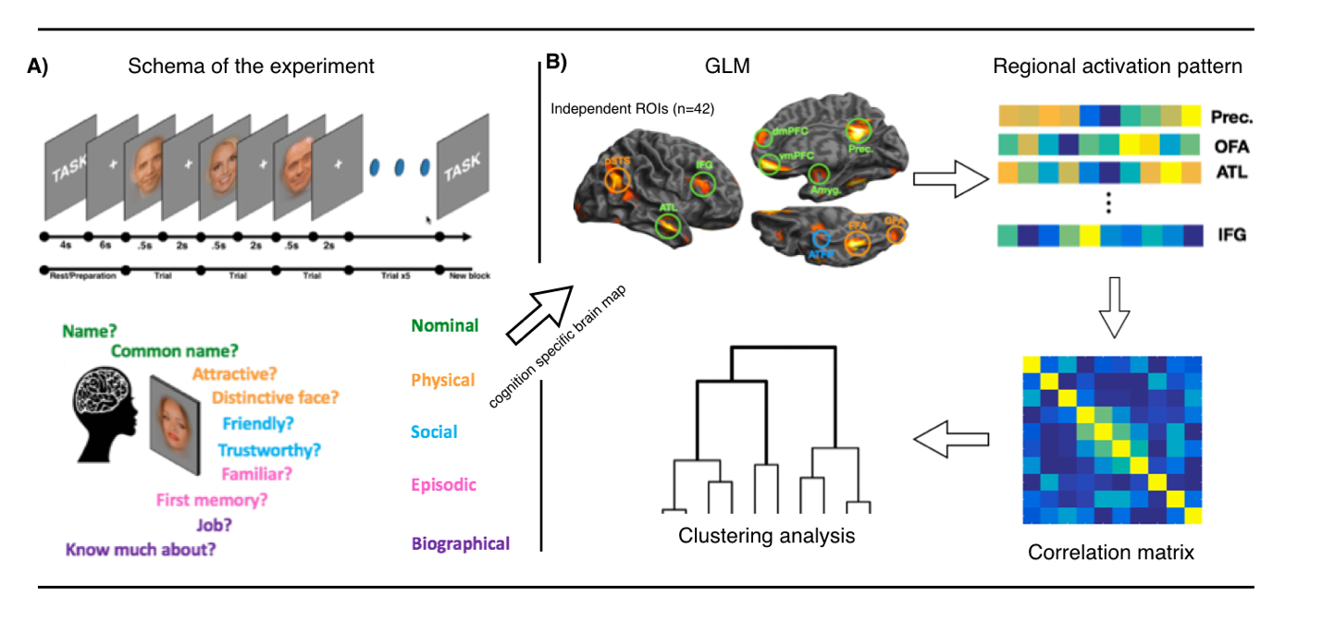

*Figure (1).* ***(A)*** *Top: Schematic representation of the experiment. Experimental blocks were preceded by 4s of instruction screen, and 6s fixation point. Each trial consisted of .5s face presentation and 2s fixation. Bottom: five domains of person knowledge and two questions per domain are noted in different colours.* ***(B)*** *Data analysis schematic. ROI beta averages for ten tasks were extracted from each ROI, correlated and subjected to RSA.*

## Data Acquisition

Participants were scanned at the Center for Mind/Brain Sciences (CIMeC), University of Trento, Italy. Data was collected using Bruker BioSpin MedSpec 4T, with 8-channel phased-array head coil. Five runs of 209 echo-planar volumes, consisting of 34, AC-PC aligned axial slices were acquired while participants performed the task (FOV = 64mm x 64mm, TR=2.5s, TE=33, FA=73°). Voxel size was 3x3x3mm with a 1mm gap. In addition to functional data, a whole brain T1 MPRAGE anatomical image was acquired (whole brain (FOV= 256x224, 176 1mm axial slices).

## ROI definition

Regions of interest were selected from an independent (N=42) experiment, conducted for high power functional localisation. In the localiser experiment participants performed a 1-back matching task with 12 second blocks of famous faces, common animals or common objects.

The contrast faces >animals+tools (voxel p < .001; cluster p < .05 FWE corrected) was used to identify face selective peaks (table 2)**.**  7.5mm radius spheres were drawn around the peak voxels and task evoked brain responses (betas) were extracted for each subject.

To investigate differences in pSTS/Angular gyrus (see: introduction) we anatomically constrained the volume with angular and superior temporal gyri masks. Then the masks were inflated, and the overlap was removed. This allowed us to distinguish face selective anatomical activation within anatomical angular and superior temporal gyri within anatomical boundaries.

***Table 3: ROI sphere centre coordinates***

Peak coordinates for regions active in the localiser experiment (n=42) and ROI sizes in voxels after thresholding.

|  |  |  |  |  |  |
| --- | --- | --- | --- | --- | --- |
| **Region** | **Hemisphere** | **X(mni)** | **Y(mni)** | **Z(mni)** | **ROI size (voxels)** |
| Precuneus | Medial | 3 | -52 | 29 | 81 |
| OFA | Right | 30 | -91 | -10 | 65 |
| Left | -33 | -88 | -10 | 49 |
| FFA | Right | 42 | -46 | -22 | 81 |
| Left | -39 | -46 | -22 | 30 |
| IFG | Right | 39 | 17 | 23 | 44 |
| Left | -36 | 20 | 26 | 38 |
| ATL | Left | -60 | -7 | -19 | 69 |
| Right | 57 | -7 | -19 | 81 |
| Amygdala | Left | -21 | -10 | -13 | 62 |
| Right | 21 | -7 | -16 | 59 |
| dmPFC | Medial | 6 | 59 | 23 | 59 |
| vmPFC | Medial | 3 | 50 | -19 | 66 |
| OFC | Right | 33 | 35 | -13 | 58 |
| Left | -33 | 35 | -13 | 27 |
| ATFP | Right | 33 | -10 | -40 | 39 |
| Left | -36 | -10 | -34 | 24 |
| Angular | Left | -48 | -67 | 35 | 68 |
| Right | 42 | -64 | 35 | 57 |
| pSTS | Left | -48 | -49 | 14 | 54 |
| Right | 48 | -55 | 14 | 71 |

## Data Analysis

Data was pre-processed with SPM12. Functional images were realigned to account for motion, grey matter segmented, warped into common space and smoothed with 8mm FWHM kernel. Subject specific response estimates (beta weights) were derived by fitting a general linear model (GLM) to the data. 12 regressors (10 tasks, 2 controls) were included as explanatory variables. Six motion parameters from re-alignment procedure were included as regressors of no interest.

We drew 7.5mm spheres around chosen coordinates (table 2) and extracted the mean beta value significantly active at p<0.001within those ROIs. To isolate the magnitude of cognitive response, we subtracted beta value for 1-back matching face control task from each experimental task.

## Multivariate Analyses

ROI responses across tasks were averaged across voxels and correlated to obtain a dissimilarity matrix (1-*r*), which was then subjected to Ward hierarchical agglomerative clustering. For task similarity analysis the matrix was transposed before correlating so that similarity matrix consisted of task correlation across ROIs.

# Results

## Behavioural Data

Mean Reaction time (RT) was M = 1203msec, SD = 111msec. Subjects reacted fastest during full name task (M=1110ms, SD=120ms), and slowest during common name task (M=1386ms, SD = 200ms). RTs differed across the ten tasks *F*(9, 190) = 17.13, p < .001. Critically, this RT effect did not persist when tasks were collapsed into the five domains of knowledge used in the imaging analysis (i.e. “Nominal“, “Physical“, “Social“, “Episodic“, “Semantic“) *F*(4, 95) = 2.21 p = .076. RT did not significantly differ between face (M = .71, SD = .11) and place (M = .68, SD = .12) control 1-back matching tasks *t*(18) = 1.96, p = .066.

Mean ratings ranged from M = 2.2, *SD* = 0.25 (attractiveness task) to M = 3.1, *SD* = .38 (full name task). Ratings differed across 10 exemplar tasks *F*(4.8, 91.7) = 27.741, p < .001 (GG correction) and 5 cognitive domains F(4,76) = 20.03, p < .001. Faces were rated highest on attractiveness (M=2.79, SD = .025) and lowest during full name access (M=1.82, SD = .38). To check whether task ratings influence task representation in the brain, we constructed RSA model of similarly rated tasks and compared it task similarity across the network (see: Cognitive Taxonomy). The relationship between rating similarity and cognitive taxonomy did not reach significance *t*(19) = -.78. p = .442.

***Role of regions in access to person knowledge.***

To assess the global importance of access to person knowledge in the core and extended systems for person perception/knowledge, we compared the average regional increase when participants accessed the 10 variants of person knowledge, compared to the one-back matching task on famous faces. The results are shown in figure 2.

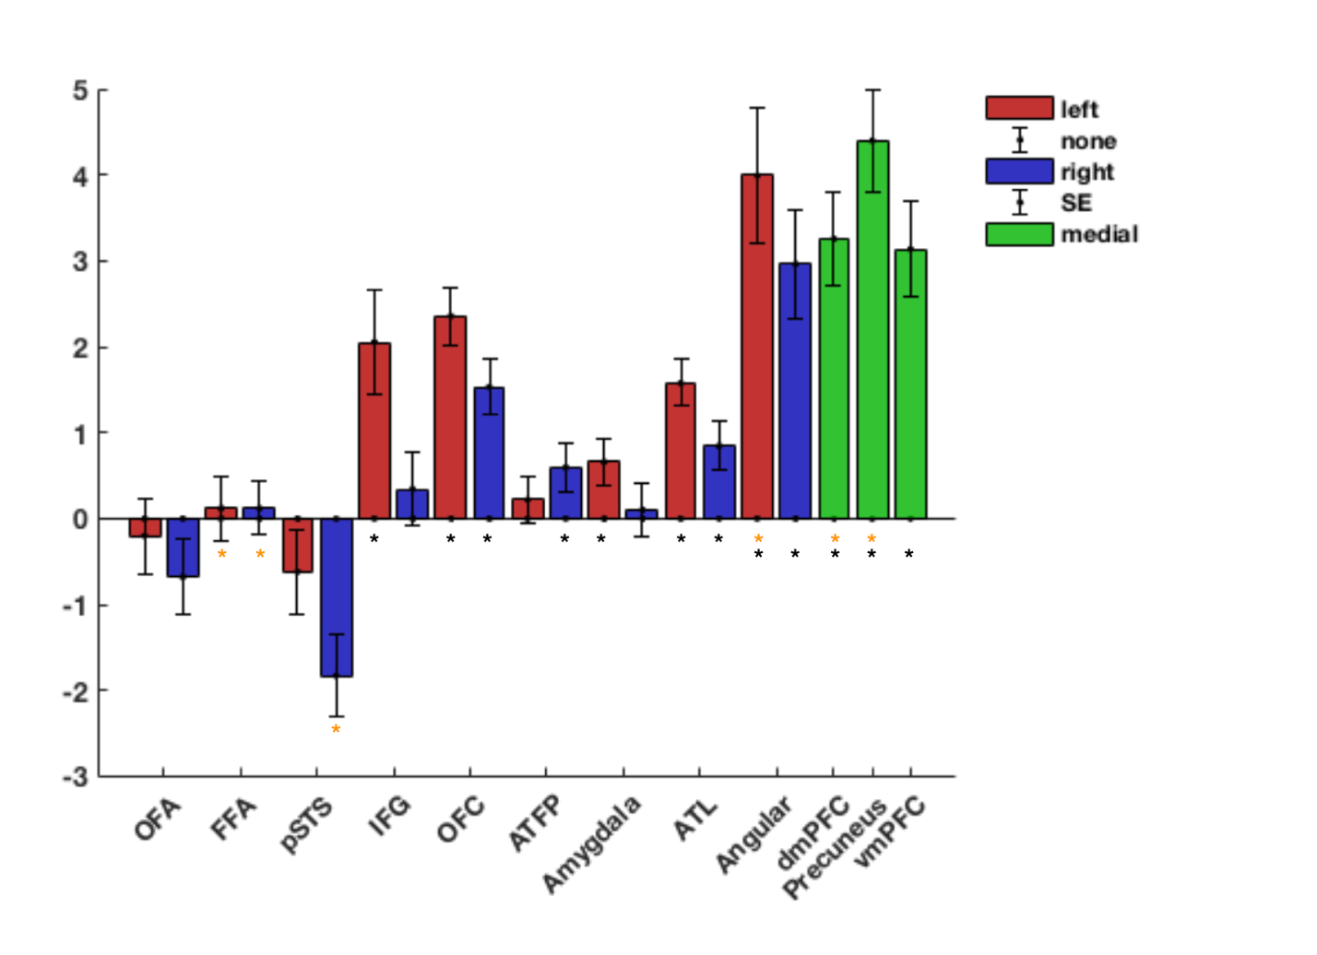

***Figure 2: Regional Responsiveness to Access to Person Knowledge (Task > Face Control). Yellow stars indicate a face selective response (Face Control > Monument Control), black stars indicate significant response for access to person knowledge (Task > Face Control). P < .05***

The most apparent distinction is between regions of the core system, which show no increase in activity (t(19) = -1.69, p = .11) and other elements of the network (t(19) = 6.98, p < .001). A second clear organisational feature of person knowledge is the left lateralisation of this process, with left hemisphere regions showing a greater relative increase when accessing person knowledge than there right hemisphere counterparts (t(19) = 4.67, p < .001).

Individually, regions of the extended system associated with internalised cognition were all strongly recruited during access to person knowledge (t-values > 4.6, p-values < .001).Lateral frontal regions, the IFG and lateral OFC show an increased response most consistently in the left, with the right IFG failing to show a significant modulation. More subtle increases are seen in medial temporal lobe structures, with only the left amygdala and the right ATL exhibiting significant modulation.

**The Role of Cognitive Domain across the Person Knowledge Network**

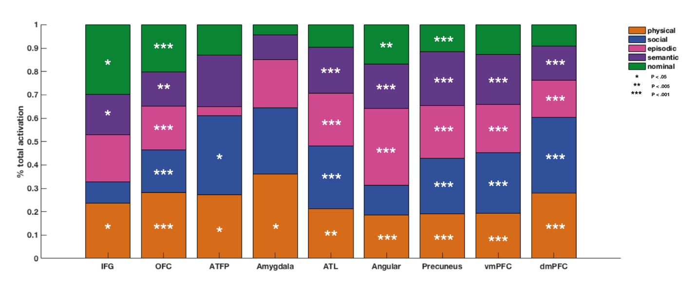

*Figure 3. Regional preference patterns. Percentage of total activation dedicated to each cognitive domain. Stars denote significance threshold. Most regions are involved in most cognitive efforts. It can also be seen that regions that respond to episodic knowledge ten to respond to semantic access as well.*

To investigate the role of different kinds of knowledge in the person knowledge network, figure 3 shows the scaled importance of each cognitive domain in those regions that were significantly activated during access to person knowledge. Here we focus only on regions that showed at least a unilateral increase when person knowledge is accessed. For simplicity, we have collapsed across hemisphere. Significant interaction between domain and hemisphere were present only in IFG (F(4,76) = 2.508, p = 0.49).

All domains of knowledge are represented in a distributed fashion across multiple regions. Physical knowledge involved all regions, while nominal knowledge involved the least amount of brain regions. Regions that respond to episodic knowledge are also involved in semantic knowledge, and mostly engage internalised cognition regions.

**The ATL is weighted towards Social not Nominal knowledge.**

The involvement of ATL in social or nominal (proper names) is a matter of current contention (Grabowski et al., 2001; Olson et al., 2013). We exploited the presence of all these cognitive aspects within one single study to address their relative importance in bilateral ATL. ANOVA revealed significant differences across cognitive domains (*F*(4, 95) = 8.13, p = < .001). A planned comparison between Social and Nominal tasks showed that access to social knowledge recruited this region to a greater extent than access to nominal knowledge t(19) = 5.79, p < .001, which did not show a significant increase compared to control t(19) = 2.08, p=.052Follow up analyses revealed that, while the largest response was evident during access to social knowledge, this was not significantly greater than episodic, factual or physical cognitive domains, each of which showed a greater response than the nominal tasks (post hoc: *t*-values all > 2.49, all *p*-values < .02, uncorrected). The response to the nominal tasks were not diminished in all regions, with IFG responding more strongly to access to nominal than social knowledge (t(19) = 3.1, p = .006).

**Perceptual and non-perceptual processing in the** **pSTS/Angular**

Here we sought to test whether the pSTS and AG have diverse functional roles. The effect was apparent even at a global level, (cf figure 2).Notably, while the pSTS showed a suppressed response during access to stored person-knowledge (pSTS left: t(19)=-1.26, ns.; right: t(19)=-3.81, p=.001), the angular gyrus conversely showed a robust response (AG left: t(19)=5.81, p<.0001.; right: t(19)=2.99, p=.01), underscoring the functional subdivision of these regions of the TPJ. This difference was also apparent in the global laterality pattern. pSTS showed a stronger inhibition in response on the right (t(19) = 3.47, p=.003), consistent with the pattern of right laterality in core regions. Conversely, there was no laterality effect in global response of the angular gyrus (t(19) = 1.57, p .134).

At the level of the single cognitive domain (see figure 3) an increased response in AG was evident across each cognitive domain (t > 3.12, p > .006; see figure x) while the pSTS did not show and increase for any cognitive domain **~~(@aidas, what was the p value for physical knowledge. @done, p value for physical knowledge was 't(19) = -1.14,p = 0.2703').~~** Finally, while cognitive domain did not have a variable effect in pSTS at the univariate level, the angular gyrus responded more during episodic memory retrieval than any other task (t > 2.8, *p* < .010). Collectively, these results demonstrate at the univariate level a pattern a responsivity in the pSTS consistent with core perceptual processing and a profile in the AG consistent with access to knowledge. Differences in inter-regional coordination patterns will be discussed in the next section.

## Inter-Regional Coordination and Network organisation

Which brain regions work together to accomplish the person-knowledge network’s varied functions?  The functional coordination between ROIs was examined through a network level Representational Similarity Analysis (*netRSA)***.** The ten task-induced beta patterns were correlated between each pair of ROIs and subjected to hierarchical clustering analysis (see figure 1 and methods). The validity of this netRSA approach is confirmed by the close proximity of left and right regional homologues (figure 4). In all cases, despite the anatomical distance, a given ROI’s cognitive profile matched most closely to that of its contralateral counterpart. An RSA template model (figure 4), confirmed the high reliability of this effect across subjects (t(19) = 13.89,p < 0.0001). This result underscores the commonality of function between hemispheric homologues.

At a descriptive level, netRSA revealed the expected cognitive clustering of core regions (OFA, FFA, pSTS). Interestingly, the lateral frontal regions the orbito-frontal and inferior frontal gyri cluster with the core system, rather than the other components of the extended system (OFC & IFG; Cluster 1,’Core-Frontal’,red).  To test if the IFG coordinates more closely with core or extended systems, we built competing models see figure 4. Post hoc comparisons of the goodness of fit between the two competing models confirmed that lateral frontal regions co-ordinate more closely with core than other extended system regions t(19) = 3.09, p = .006). Considering regions separately, this effect persisted for IFG (*t*(19) = 4.35, p < 0.0003), while no preference was evident for OFC (*t*(19) = 1.59, p = 0.13).

Within the extended system, regions overlapping with those associated with internalised cognition form a distinct cluster (Cluster 2,’extended-DMN’,green) from medial temporal amygdala and anterior face patch (Cluster 3,’extended-ventromedial’,purple). A planned comparison of whether the ATFP groups more closely with the core or extended system resulted in no evidence for either hypothesis (t(19) = -0.21, p=0.84).

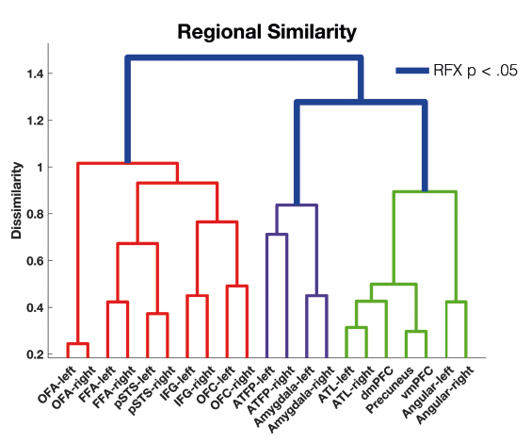

*Figure 4. ROI clustering. First major division separates core together with IFG & OFC from the rest of the extended system (red vs green + purple). Within the extended system, a further division can be seen between extended-DMN and extended-VM regions (green, purple).*

## Cognitive Similarity in the Brain

To address the fundamental question of how different forms of cognition relate to one another, netRSA was performed across ROIs to investigate how similar the neural representations of cognitive domains in the brain are (Figure 5). Despite the variety in tasks and reactions times, the task pairs for each cognitive domain (e.g. ‘common name’ and ‘full name’ for nominal knowledge retrieval) are grouped together. This illustrates the efficacy of netRSA in this context as well as providing another internal validation. To test our a priori selection of task couplets, we built a model to test their similarity. Results show that tasks from the same cognitive domain have highly similar representation across the person knowledge network (t(19) = 4.14,p = 0.0006).

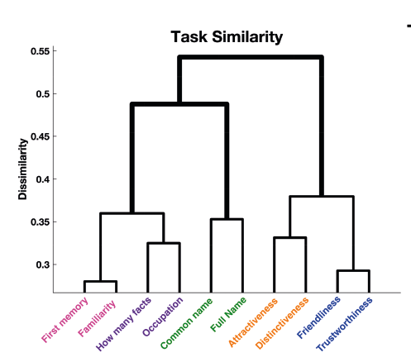

*Figure 5. Task similarity in core+extended system ROIs. Tasks are grouped according to the domain they were sampled from. Episodic and semantic knowledge retrieval tasks elicit differentiable patters than nominal, physical or social tasks.*

At the next level of hierarchical clustering, results reveal three distinct cognitive clusters. Network activity is more similar for physical (yellow) and social (blue) knowledge than to other forms of knowledge. Likewise, episodic (pink) and biographical (purple) knowledge form a cluster, that is distinct from nominal knowledge. We compared competing models (see figure 5) to make inference about whether semantic knowledge more closely relates to the episodic or nominal domain. Results confirm that semantic knowledge is more similar to episodic memories, than nominal knowledge t(19) = 3.97, p = .0008).

## Whole Brain Analysis - Beyond the person-selective network

The motivation of this project was to gain insight into the normal function of the well-characterised network for person knowledge by strongly pushing the system towards access to different domains of knowledge. While we focus on the network for perceiving and knowing about others, it is not accomplished solely by the person knowledge system. It is important to consider that these systems presumably pair and couple with brain regions outside the person-selective network, with the network’s periphery potentially driving transient specialisation within the network itself.

A whole brain analysis comparing each cognitive domain to the average of the other domains is presented in figure 6. Notably, no regions demonstrated a significant preference for two or more cognitive domains, consistent with non-overlapping cognitive specialisation outside the person knowledge network. Access to nominal knowledge is characterised by a broad pattern of activation, stronger on the left hemisphere than the right (figure 6, table 4). It encompasses left hemispheric sites associated with language production and comprehension, as well as the posterior middle/inferior temporal gyrus. Conversely, accessing perceptual knowledge is more pronounced in the right hemisphere, predominantly in superior portion of the IFG. Social knowledge retrieval more strongly activated left ATL and an anterior patch of dmPFC. Recalling episodic memories involved the precuneus, angular gyrus as well as right lateral frontal pole and bilateral patches of the superior frontal gyrus. Purely factual knowledge retrieval tasks did not produce significant clusters of activity.

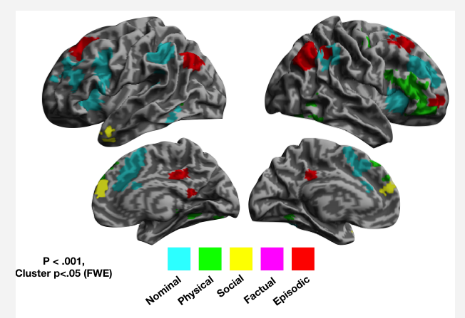

*Figure 6. Whole brain map of different cognitive domains. Factual knowledge did not elicit significant clusters of activity.*

*Table 4: Whole brain significant peak activation for different cognitive tasks (see also: figure 6)*

|  |  |  |  |  |  |
| --- | --- | --- | --- | --- | --- |
| Domain | Region | Hemisphere | cluster | | Peak |
| p(FWE-corr) | equivk | T |
| Episodic | Angular | Right | 0.000 | 507 | 8.06 |
| Angular | Left | 0.000 | 264 | 6.57 |
| SFG | Right | 0.000 | 216 | 5.68 |
| Precuneus | Medial | 0.000 | 142 | 5.68 |
| SFG | Left | 0.001 | 125 | 4.77 |
| OFC | Right | 0.017 | 71 | 4.65 |
| Precuneus | Medial | 0.032 | 61 | 4.16 |
| Social | dmPFC | Medial | 0.000 | 396 | 6.57 |
| ATL | Left | 0.001 | 130 | 4.58 |
| Physical | IFG | Right | 0.000 | 616 | 5.72 |
| FFA | Right | 0.000 | 274 | 4.86 |
| PMC | Right | 0.006 | 87 | 4.38 |
| Amygdala | Right | 0.020 | 68 | 4.37 |
| dmPFC | Medial | 0.000 | 253 | 4.34 |
| FFA | Left | 0.004 | 94 | 4.24 |
| IPS | Right | 0.005 | 92 | 3.93 |
| Nominal | IFG | Left | 0.000 | 1188 | 6.99 |
| SMA | medial | 0.000 | 1670 | 6.40 |
| Angular | Left | 0.000 | 370 | 6.35 |
| Angular | Right | 0.000 | 265 | 5.31 |
| FFA | Left | 0.003 | 97 | 4.70 |

# Discussion

Cognitive processes are distributed across networks of regions. By having our participants perform a broad range of cognitive tasks and exploiting data complexity through derivations of statistical tools such as RSA, we could focus on the subtle differences in inter-regional coordination that endow distributed cortical networks their considerable cognitive flexibility. By relating task activity not only to a baseline but to activity during other tasks we were able to establish regional preferences which allowed us to tackle specific hypotheses about regional function. Leveraging multivariate methods provided insight into regional coordination, uncovering principles of network organisation as well as the similarity between different cognitive processes allowing us to build a cognitive taxonomy grounded in brain representation.

**Functional subdivisions between pSTS and angular gyrus**

The pSTS was originally designated as part of the core system (Haxby, Hoffman, & Gobbini, 2000b). Over the years this classification has become less clear and pSTS has been reclassified as part of both core and extended systems (Gobbini & Haxby, 2007). The pSTS is part of a cortical region of heterogeneous function, the temporal parietal junction (TPJ), which includes pSTS, the angular gyrus and the supramarginal gyrus. In this study, we anatomically divided the person selective patch into pSTS and angular gyrus components. We observed a striking dissociation across this subdivision. Firstly, AG exhibited a strong global response to access to person related knowledge while pSTS was either unresponsive (left) or supressed (right) during access to person knowledge compared to the face repetition-detection control task. Secondly, the response profile across each of the cognitive tasks grouped them differently, with pSTS clustering with other core regions while AG strongly clustered with regions of the extended system associated with intrinsic cognition.

This result strongly supports the reclassification of ‘pSTS’ into face-selective pSTS and person-selective angular gyrus. The results indicate that the contiguous TPJ activation reported during the viewing of familiar faces is functionally heterogeneous, divided into an angular gyrus component that responds to non-visual theory of mind (Saxe & Powell, 2006) and amodal access to person knowledge (Fairhall & Caramazza, 2013b) and a pSTS component involved in face perception. Future work will determine how these anatomically adjacent brain regions coordinate across other cognitive processes but within the context of person-related cognition, the appear to be highly distinct.

## Regional tuning of ATL

Different hypotheses propose that ATL might mediate person-specific social knowledge (Olson et al., 2007) or proper naming (Semenza, 2011). Here we directly contrasted these two hypotheses and observed that ATL responds strongly to social knowledge and is unresponsive to nominal knowledge retrieval. This is in apparent contrast to early positron emission studies which show the strong activation of the region during over naming (Gorno-Tempini et al., 1998; Grabowski et al., 2001). However, it is consistent with the finding that the ATL responds equally to familiar people whether or not the name is known by the participant (Gesierich et al., 2011). The reason for these disparities may lie in fMRI signal drop-off in the ATL (Devlin et al., 2000) or in specific representational or phonological demands associated with overt speech production. Alternatively, it may be that ATL activation observed in earlier studies was not specific to nominal knowledge but rather, to generalised activation of person knowledge. Indeed, this generality is evident in the present study where access to semantic, episodic and physical cognitive domains, as well as social, activated ATL. While social knowledge did not produce a stronger response in ATL than these other three domains, it is noteworthy that, in contrast to the ROI analysis, in the whole brain analysis (figure 6) only social knowledge showed a significant cognitive selective response in the ATL.

**Regional coordination across the person knowledge network**

Elements of the network for person knowledge coordinate to form a diverse range of functions. Here, in contrast to investigating functional connectivity over time (e.g. (Fairhall & Ishai, 2007)) we consider how these regions functionally coordinate over different tasks in response to their varied cognitive domains. Consistent with classic models (Haxby, Hoffman, & Gobbini, 2000b) we observed that functional coordination between core perceptual (OFA, FFA and pSTS) regions was high. Interestingly, we observed that the fronto-lateral components of the extended system, IFG and OFC, coordinated closely with these core regions rather than other elements of the classic extended system. It is notable that these fronto-lateral regions, particularly IFG, are closely related to extrinsic, task-activated, networks, distinguishing them from extended regions associated with the anti-correlated intrinsic resting state network (Fox et al., 2005). Additionally, during access to stored knowledge, the fronto-lateral IFG is implicated in guiding access to relevant information (Martin & Chao, 2001; Thompson-Schill, 2003; A. D. Wagner, Paré-Blagoev, Clark, & Poldrack, 2001)suggesting that IFG and OFC are modulating core system regions.

Other components of the extended system appear to coordinate most closely with each other over tasks. Hierarchical clustering revealed an apparent dissociation between medial temporal components (ATFP, amygdala) and those associated with internalised cognition (vmPFC, precuneus, ATL, AG), although this was not confirmed by statistical analysis and future work will be needed to verify this grouping. A planned comparison of whether ATFP grouped most closely with core or extended systems revealed no evidence in either direction. Both responded to at least one type of task, confirming their role in person knowledge – but their position in the hierarchy remains unclear.

## Cognitive taxonomy in person knowledge

By considering the similarity between the neural substrates of different cognitive domains we can gain insight into the relationship between these cognitive domains. We addressed this question within the network for perceiving and knowing about others by comparing the profile of each task across the 21 ROIs comprising this network. We observed that for each task, despite variations in reaction times and task structure, that the two task-exemplars for each of the five cognitive domains, reliably clustered with their counterpart. Showing that cognitive domain is the primary grouping factor of activation patterns across this network.

The general pattern of cognitive clustering across the regions suggests that social and perceptual knowledge share similar neural patterns, as do semantic and episodic knowledge with nominal being represented somewhat distinctly. These findings fall broadly within hypothesised domain-specificity boundaries (Spunt & Adolphs, 2017) suggesting that declarative memory (episodic, semantic tasks) and language (nominal tasks) are part of the ‘cognitive’ macro-domain, while facial reception (physical tasks) and theory of mind (social tasks) are part of the ‘social’ macro-domain.

Of specific interest to us was the relationship between episodic, semantic and nominal knowledge. A classic distinction in forms of declarative memory is between episodic (personal experience) and semantic (general knowledge) (Tulving, 1972). The term ‘semantic knowledge’ refers to a broad range of knowledge about objects, factual knowledge and word meaning. Here we specifically contrasted competing components comparing whether semantic memory in the form of factual knowledge about people was more closely related to the linkage of an entity to their name or to our personal experience and memories about that person. Comparing these competing models, we observed that, within the person-knowledge cortical network, semantic memory robustly clustered more closely to episodic than nominal access. This grouping is roughly apparent in the tuning profiles presented in figure (3), where episodic and semantic domains load most heavily on regions associated with intrinsic cognition while nominal knowledge follows a different topography - engaging only parts of the intrinsic network as well as regions outside of it, namely the IFG.

In a broader sense, this result suggests that for some forms of knowledge, the episodic and semantic line blurs. While knowing the elementary school one attended may be different to knowing that a dog is a quadruped, it may not be distinct than knowing that Buzz Aldrin was the second person to step foot on the moon. **[older reference here? @Scott, what do you mean]**

**Cognitive domain across the whole brain**

In the study, we sought to understand how different elements of the person knowledge network, active spontaneously when we view familiar people (Gobbini & Haxby, 2007), contribute to our diverse array of person related knowledge. To do this we perturbed the system towards five difference cognitive domains to understand regional processing bias. However, these cognitive domains are not accomplished solely within the person knowledge network and a whole brain analysis revealed the cognitive-domain selective contributions of brain regions outside this network. Nominal access generally recruited language regions in the supramarginal gyrus, lateral PFC and dorsomedial PFC (Price, 2012). The activation of language regions for nominal knowledge confirms that this task was closely linked to language processes. Social knowledge preferentially recruited a section of the left ATL and an anterior section of dorsomedial PFC consistent with previous findings (Adolphs, 2009). Physical knowledge engaged broad parts of right lateral PFC as well as small clusters in medial temporal and occipital areas in line with previous findings on perceptual areas engaged when retrieving knowledge about physical attributes (Kan, Barsalou, Solomon, Minor, & Thompson-Schill, 2010). Episodic access recruited regions involved in mental time travel (Viard et al., 2011) such as bilateral AG and the precuneus as well as superior frontal regions.

**Conclusion**

The current study examined how the distributed cortical network for perceiving and knowing about others coordinates to accomplish its diverse range of cognitive functions. We observed that elements of this network work together across different domains of knowledge in manner generally consistent with classical core and extended systems, with the exception that lateral frontal regions coordinate more closely with the core that extended system. Furthermore, by examining the similarity of network level cortical representations across different tasks, we were able to reconstruct a cognitive taxonomy that reflected how similar different cognitive domains are to one another in the brain. Interestingly, we observed that access to factual semantic knowledge employs neural substrates more similar to episodic memory than to language-related nominal knowledge. In addition, we directly confronted the role of ATL in nominal and social cognition and found a clear preference for access to social knowledge. Finally, we anatomically divided the person selective activation of TPJ into pSTS and angular gyrus components and observed that both the global response to cognitive access and the profile of activation across different cognitive domains clearly distinguished these regions into a perceptual pSTS and a cognitive angular gyrus. Collectively, these results provide fresh insight into the organisation of person related knowledge and future work will determine whether these principles extend to the representation of knowledge in general.

References

Adolphs, R. (2002). Neural systems for recognizing emotion., *12*(2), 169–177. http://doi.org/10.1016/s0959-4388(02)00301-x

Adolphs, R. (2003). Cognitive neuroscience: Cognitive neuroscience of human social behaviour. *Nature Reviews Neuroscience*, *4*(3), 165–178. http://doi.org/10.1038/nrn1056

Adolphs, R. (2009). The Social Brain: Neural Basis of Social Knowledge, *60*(1), 693–716. http://doi.org/10.1146/annurev.psych.60.110707.163514

Binder, J. R., Desai, R. H., Graves, W. W., & Conant, L. L. (2009). Where is the semantic system? A critical review and meta-analysis of 120 functional neuroimaging studies. *Cerebral Cortex*, *19*(12), 2767–2796. http://doi.org/10.1093/cercor/bhp055

Bortolon, C., Capdevielle, D., & Raffard, S. (2015). Face recognition in schizophrenia disorder: A comprehensive review of behavioral, neuroimaging and neurophysiological studies. *Neuroscience & Biobehavioral Reviews*, *53*, 79–107. http://doi.org/10.1016/j.neubiorev.2015.03.006

Bzdok, D., Langner, R., Caspers, S., Kurth, F., Habel, U., Zilles, K., et al. (2010). ALE meta-analysis on facial judgments of trustworthiness and attractiveness. *Brain Structure and Function*, *215*(3-4), 209–223. http://doi.org/10.1007/s00429-010-0287-4

Calder, A. J., & Young, A. W. (2005). Understanding the recognition of facial identity and facial expression. *Nature Reviews Neuroscience*, *6*(8), 641–651. http://doi.org/10.1038/nrn1724

Devlin, J. T., Russell, R. P., Davis, M. H., Price, C. J., Wilson, J., Moss, H. E., et al. (2000). Susceptibility-Induced Loss of Signal: Comparing PET and fMRI on a Semantic Task. *NeuroImage*, *11*(6), 589–600. http://doi.org/10.1006/nimg.2000.0595

Fairhall, S. L., & Caramazza, A. (2013a). Brain regions that represent amodal conceptual knowledge. *The Journal of Neuroscience: the Official Journal of the Society for Neuroscience*, *33*(25), 10552–10558. http://doi.org/10.1523/JNEUROSCI.0051-13.2013

Fairhall, S. L., & Caramazza, A. (2013b). Category-selective neural substrates for person- and place-related concepts. *Cortex; a Journal Devoted to the Study of the Nervous System and Behavior*, *49*(10), 2748–2757. http://doi.org/10.1016/j.cortex.2013.05.010

Fairhall, S. L., & Ishai, A. (2007). Effective Connectivity within the Distributed Cortical Network for Face Perception, *17*(10), 2400–2406. http://doi.org/10.1093/cercor/bhl148

Fairhall, S. L., Anzellotti, S., Ubaldi, S., & Caramazza, A. (2014). Person- and place-selective neural substrates for entity-specific semantic access. *Cerebral Cortex*, *24*(7), 1687–1696. http://doi.org/10.1093/cercor/bht039

Fox, M. D., Snyder, A. Z., Vincent, J. L., Corbetta, M., Van Essen, D. C., & Raichle, M. E. (2005). The human brain is intrinsically organized into dynamic, anticorrelated functional networks. *Proceedings of the National Academy of Sciences*, *102*(27), 9673–9678. http://doi.org/10.1073/pnas.0504136102

Gauthier, I., Tarr, M. J., Moylan, J., & Skudlarski, P. (2000). The fusiform “face area” is part of a network that processes faces at the individual level. *Journal of Cognitive …*. http://doi.org/10.1162/089892900562165

Gesierich, B., Jovicich, J., Riello, M., Adriani, M., Monti, A., Brentari, V., et al. (2011). Distinct Neural Substrates for Semantic Knowledge and Naming in the Temporoparietal Network, *22*(10), bhr286–2226. http://doi.org/10.1093/cercor/bhr286

Glosser, G., Salvucci, A. E., & Chiaravalloti, N. D. (2003). Naming and recognizing famous faces in temporal lobe epilepsy. *Neurology*, *61*(1), 81–86. http://doi.org/10.1212/01.WNL.0000073621.18013.E1

Gobbini, M. I., & Haxby, J. V. (2007). Neural systems for recognition of familiar faces. *Neuropsychologia*, *45*(1), 32–41. http://doi.org/10.1016/j.neuropsychologia.2006.04.015

Gorno-Tempini, M. L., Price, C. J., Josephs, O., Vandenberghe, R., Cappa, S. F., Kapur, N., et al. (1998). The neural systems sustaining face and proper-name processing. *Brain*, *121 (Pt 11)*, 2103–2118.

Grabowski, T. J., Damasio, H., Tranel, D., Ponto, L. L. B., Hichwa, R. D., & Damasio, A. R. (2001). A role for left temporal pole in the retrieval of words for unique entities. *Human Brain Mapping*, *13*(4), 199–212. http://doi.org/10.1002/hbm.1033

Greene, J. D., Sommerville, R. B., Nystrom, L. E., Darley, J. M., & Cohen, J. D. (2001). An fMRI investigation of emotional engagement in moral judgment. *Science*, *293*(5537), 2105–2108. http://doi.org/10.1126/science.1062872

Haxby, J. V., Hoffman, E. A., & Gobbini, M. I. (2000a). The distributed human neural system for face perception. *Trends in Cognitive Sciences*, *4*(6), 223–233. http://doi.org/10.1016/S1364-6613(00)01482-0

Haxby, J. V., Hoffman, E. A., & Gobbini, M. I. (2000b). The distributed human neural system for face perception. *Trends in Cognitive Sciences*. http://doi.org/10.1016/S1364-6613(00)01482-0

Heide, Von Der, R. J., Skipper, L. M., & Olson, I. R. (2013). Anterior temporal face patches: a meta-analysis and empirical study, *7*. http://doi.org/10.3389/fnhum.2013.00017

Hein, G., & Knight, R. T. (2008). Superior Temporal Sulcus—It's My Area: Or Is It? *Dx.Doi.org*, *20*(12), 2125–2136. http://doi.org/10.1162/jocn.2008.20148

Huth, A. G., de Heer, W. A., Griffiths, T. L., Theunissen, F. E., & Gallant, J. L. (2016). Natural speech reveals the semantic maps that tile human cerebral cortex. *Nature*, *532*(7600), 453–458. http://doi.org/10.1038/nature17637

Kan, I. P., Barsalou, L. W., Solomon, K. O., Minor, J. K., & Thompson-Schill, S. L. (2010). ROLE OF MENTAL IMAGERY IN A PROPERTY VERIFICATION TASK: FMRI EVIDENCE FOR PERCEPTUAL REPRESENTATIONS OF CONCEPTUAL KNOWLEDGE. *Cognitive Neuropsychology*, *20*(3-6), 525–540. http://doi.org/10.1080/02643290244000257

Kanwisher, N., McDermott, J., & Chun, M. M. (1997). The fusiform face area: a module in human extrastriate cortex specialized for face perception. *The Journal of Neuroscience : the Official Journal of the Society for Neuroscience*, *17*(11), 4302–4311. Retrieved from https://www.scopus.com/record/display.uri?eid=2-s2.0-0030911020&origin=inward&txGid=420A0EC51454AE0F07417042C496053F.wsnAw8kcdt7IPYLO0V48gA%3a11

Koster-Hale, J., Richardson, H., Velez, N., Asaba, M., Young, L., & Saxe, R. (2017). Mentalizing regions represent distributed, continuous, and abstract dimensions of others' beliefs. *NeuroImage*, *161*, 9–18. http://doi.org/10.1016/j.neuroimage.2017.08.026

Martin, A., & Chao, L. L. (2001). Semantic memory and the brain: structure and processes. *Current Opinion in Neurobiology*, *11*(2), 194–201.

Minnebusch, D. A., & Daum, I. (2009). Neuropsychological mechanisms of visual face and body perception. *Neuroscience & Biobehavioral Reviews*, *33*(7), 1133–1144. http://doi.org/10.1016/j.neubiorev.2009.05.008

Moeller, S., Freiwald, W. A., & Tsao, D. Y. (2008). Patches with links: a unified system for processing faces in the macaque temporal lobe. *Science*, *320*(5881), 1355–1359. http://doi.org/10.1126/science.1157436

Moran, J. M., Lee, S. M., & Gabrieli, J. D. E. (2011). Dissociable Neural Systems Supporting Knowledge about Human Character and Appearance in Ourselves and Others. *Dx.Doi.org*, *23*(9), 2222–2230. http://doi.org/10.1162/jocn.2010.21580

Olson, I. R., McCoy, D., Klobusicky, E., & Ross, L. A. (2013). Social cognition and the anterior temporal lobes: a review and theoretical framework. *Social Cognitive and Affective Neuroscience*, *8*(2), 123–133. http://doi.org/10.1093/scan/nss119

Olson, I. R., Plotzker, A., & Ezzyat, Y. (2007). The Enigmatic temporal pole: a review of findings on social and emotional processing. *Brain*, *130*(7), 1718–1731. http://doi.org/10.1093/brain/awm052

Patterson, K., Nestor, P. J., & Rogers, T. T. (2007). Where do you know what you know? The representation of semantic knowledge in the human brain. *Nature Reviews Neuroscience*, *8*(12), 976–987. http://doi.org/10.1038/nrn2277

Price, C. J. (2012). A review and synthesis of the first 20years of PET and fMRI studies of heard speech, spoken language and reading. *NeuroImage*, *62*(2), 816–847. http://doi.org/10.1016/j.neuroimage.2012.04.062

Raichle, M. E., MacLeod, A. M., Snyder, A. Z., Powers, W. J., Gusnard, D. A., & Shulman, G. L. (2001). A default mode of brain function. *Proceedings of the National Academy of Sciences*, *98*(2), 676–682. http://doi.org/10.1073/pnas.98.2.676

Rajimehr, R., Young, J. C., & Tootell, R. B. H. (2009). An anterior temporal face patch in human cortex, predicted by macaque maps. *Proceedings of the National Academy of Sciences*, *106*(6), 1995–2000. http://doi.org/10.1073/pnas.0807304106

Ross, L. A., & Olson, I. R. (2012). What's Unique about Unique Entities? An fMRI Investigation of the Semantics of Famous Faces and Landmarks, *22*(9), 2005–2015. http://doi.org/10.1093/cercor/bhr274

Saxe, R., & Powell, L. J. (2006). It's the thought that counts: specific brain regions for one component of theory of mind. *Psychological Science*, *17*(8), 692–699. http://doi.org/10.1111/j.1467-9280.2006.01768.x

Schacter, D. L., & Addis, D. R. (2007). The cognitive neuroscience of constructive memory: remembering the past and imagining the future. *Philosophical Transactions of the Royal Society of London, Series B: Biological Sciences*, *362*(1481), 773–786. http://doi.org/10.1098/rstb.2007.2087

Semenza, C. (2011). Naming with proper names: the left temporal pole theory. *Behavioural Neurology*, *24*(4), 277–284. http://doi.org/10.3233/BEN-2011-0338

Simmons, W. K., & Martin, A. (2009). The anterior temporal lobes and the functional architecture of semantic memory. *Journal of the International Neuropsychological Society*, *15*(05), 645. http://doi.org/10.1017/S1355617709990348

Spreng, R. N., Stevens, W. D., Chamberlain, J. P., Gilmore, A. W., & Schacter, D. L. (2010). Default network activity, coupled with the frontoparietal control network, supports goal-directed cognition. *NeuroImage*, *53*(1), 303–317. http://doi.org/10.1016/j.neuroimage.2010.06.016

Spunt, R. P., & Adolphs, R. (2017). A new look at domain specificity: insights from social neuroscience. *Nature Reviews Neuroscience*, *18*(9), 559–567. http://doi.org/10.1038/nrn.2017.76

Thompson-Schill, S. L. (2003). Neuroimaging studies of semantic memory: inferring "how" from "where". *Neuropsychologia*, *41*(3), 280–292. http://doi.org/10.1016/S0028-3932(02)00161-6

Tippett, L. J., Miller, L. A., & Farah, M. J. (2000). Prosopamnesia: a selective impairment in face learning. *Cognitive Neuropsychology*, *17*(1), 241–255. http://doi.org/10.1080/026432900380599

Todorov, A., Gobbini, M. I., Evans, K. K., & Haxby, J. V. (2007). Spontaneous retrieval of affective person knowledge in face perception, *45*(1), 163–173. http://doi.org/10.1016/j.neuropsychologia.2006.04.018

Tulving, E. (1972). Episodic and semantic memory. *Organization of Memory*.

Van Overwalle, F. (2009). Social cognition and the brain: A meta‐analysis. *Human Brain Mapping*, *30*(3), 829–858. http://doi.org/10.1002/hbm.20547

Van Overwalle, F. (2011). A dissociation between social mentalizing and general reasoning. *NeuroImage*, *54*(2), 1589–1599. http://doi.org/10.1016/j.neuroimage.2010.09.043

Viard, A., Chételat, G., Lebreton, K., Desgranges, B., Landeau, B., La Sayette, de, V., et al. (2011). Mental time travel into the past and the future in healthy aged adults: An fMRI study. *Brain and Cognition*, *75*(1), 1–9. http://doi.org/10.1016/j.bandc.2010.10.009

Wagner, A. D., Paré-Blagoev, E. J., Clark, J., & Poldrack, R. A. (2001). Recovering meaning: left prefrontal cortex guides controlled semantic retrieval. *Neuron*. http://doi.org/10.1016/S0896-6273(01)00359-2

Wagner, D. D., Haxby, J. V., & Heatherton, T. F. (2012). The Representation of Self and Person Knowledge in the Medial Prefrontal Cortex. *Wiley Interdisciplinary Reviews: Cognitive Science*, *3*(4), 451–470. http://doi.org/10.1002/wcs.1183

Werner, N.-S., Kühnel, S., & Markowitsch, H. J. (2013). The Neuroscience of Face Processing and Identification in Eyewitnesses and Offenders. *Frontiers in Behavioral Neuroscience*, *7*. http://doi.org/10.3389/fnbeh.2013.00189

Wieser, M. J., & Brosch, T. (2012). Faces in Context: A Review and Systematization of Contextual Influences on Affective Face Processing. *Frontiers in Psychology*, *3*. http://doi.org/10.3389/fpsyg.2012.00471